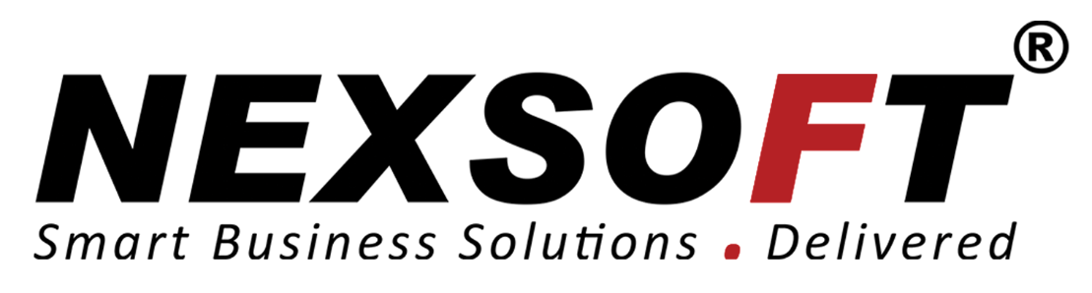

Service Agreement

Prepared for CBL Cocos(Pvt) Limited

By Nexsoft

**Table of Contents**

1. Agreement Overview 3

2. Goals & Objectives 3

3. Stakeholders 3

4. Periodic Review 4

5. Service Agreement 5

5.1. Service Scope 5

5.2. Customer Requirements 5

5.3. Service Provider Requirements 5

5.4. Service Assumptions 5

6. Service Management 6

6.1. Service Availability 6

6.2. Service Requests 6

# Agreement Overview

This Agreement represents a Service Level Agreement (“SLA” or “Agreement”) between *Nexsoft Solutions* and *CBL Cocos(Pvt) Limited* for the provisioning of IT services required to support and sustain the CBL Cocos purchasing system (LAN).

This Agreement remains valid until superseded by a revised agreement mutually endorsed by the stakeholders.

This Agreement outlines the parameters of all IT services covered as they are mutually understood by the primary stakeholders. This Agreement does not supersede current processes and procedures unless explicitly stated herein.

# Goals & Objectives

The **purpose** of this Agreement is to ensure that the proper elements and commitments are in place to provide consistent IT service support and delivery to the Customer(s) by the Service Provider(s).

The **goal** of this Agreement is to obtain mutual agreement for IT service provision between the Service Provider(s) and Customer(s).

The **objectives** of this Agreement are to:

* + Provide clear reference to service ownership, accountability, roles and/or responsibilities.
  + Present a clear, concise and measurable description of service provision to the customer.
  + Match perceptions of expected service provision with actual service support & delivery.

# Stakeholders

The following Service Provider(s) and Customer(s) will be used as the basis of the Agreement and represent the **primary** **stakeholders** associated with this SLA:

**IT Service Provider(s):** Nexsoft Solutions. (“Provider”)

**IT Customer(s):** CBL Cocos(Pvt) Limited (“Customer”)

# 

# Periodic Review

This Agreement is valid from the **Effective Date** outlined herein and is valid until further notice. This Agreement should be reviewed at a minimum once per year; however, in lieu of a review during any period specified, the current Agreement will remain in effect.

The **Business Relationship Manager** (“Document Owner”) is responsible for facilitating regular reviews of this document. Contents of this document may be amended as required, provided mutual agreement is obtained from the primary stakeholders and communicated to all affected parties. The Document Owner will incorporate all subsequent revisions and obtain mutual agreements / approvals as required.

**Business Relationship Manager:** Nexsoft Solutions

**Review Period:** Yearly (12 months)

**Previous Review Date:** 16-NOV-2016

**Next Review Date:** 16-NOV-2017

# Service Agreement

The following detailed service parameters are the responsibility of the Service Provider in the ongoing support of this Agreement.

## *Service Scope*

The following Services are covered by this Agreement;

## Manned telephone support

## Monitored email support

## Remote assistance using Remote Desktop and a Virtual Private Network where available

* + Providing updates on requirement changes (extra costs apply)
  + System maintenance, patches and bug fixes. (free until 16-NOV-2017)

## Customer Requirements

**Customer** responsibilities and/or requirements in support of this Agreement include:

* Payment for all support costs at the agreed interval.
* Reasonable availability of customer representative(s) when resolving a service related incident or request.

## Service Provider Requirements

**Service Provider** responsibilities and/or requirements in support of this Agreement include:

* Meeting response times associated with service related incidents.
* Appropriate notification to Customer for all scheduled maintenance.

## *Service Assumptions*

Assumptions related to in-scope services and/or components include:

* Changes to services will be communicated and documented to all stakeholders.

# Service Management

Effective support of in-scope services is a result of maintaining consistent service levels. The following sections provide relevant details on service availability, monitoring of in-scope services and related components.

## *Service Availability*

Coverage parameters specific to the service(s) covered in this Agreement are as follows:

* Telephone support : 9:00 A.M. to 5:00 P.M. Monday – Friday
  + Calls received out of office hours will be forwarded to a mobile phone and best efforts will be made to answer / action the call, however there will be a backup answer phone service.
* Email support: Monitored 9:00 A.M. to 5:00 P.M. Monday – Friday
  + Emails received outside of office hours will be collected, however no action can be guaranteed until the next working day.
* Remote assistance guaranteed within 72 hours during the business week.
* System updates will be delivered according to the new customer requirements and will be charged based on the requirements provided.
* Maintenance, Patches and Bug fixes will be provided free for 12 months (16-11-2016 to 16-11-2017), Then maintenance patches and bug fixes will be charged depending on the priority and time it takes for the maintenance or to develop a patch or a fix.

## *Service Requests*

In support of services outlined in this Agreement, the Service Provider will respond to service related incidents and/or requests submitted by the Customer within the following time frames:

* 0-8 hours (during business hours) for issues classified as **High** priority.
* Within 48 hours for issues classified as **Medium** priority.
* Within 5 working days for issues classified as **Low** priority.

Remote assistance will be provided in-line with the above timescales dependent on the priority of the support request.

|  |  |
| --- | --- |
| **Document Owner:** | Nexsoft Solutions |

**Version**

|  |  |  |  |
| --- | --- | --- | --- |
| Version | Date | Description | Author |
| 1.0 | 10-11-2016 | Service Level Agreement | D.A.L.B.S Ranawaka |

**Approval**

*(By signing below, all Approvers agree to all terms and conditions outlined in this Agreement.)*

|  |  |  |  |
| --- | --- | --- | --- |
| Approvers | Role | Signed | Approval Date |
| Nexsoft Solutions | Service Provider |  | 10-11-2016 |
| Cocos(Pvt) Limited | Customer |  | 10-11-2016 |